S O U T H W O O T T O N P A R I S H C O U N C I L

Minutes of a Meeting held at 7pm on Tuesday, 11th September 2018
In the Parish Council Meeting Room, Church Lane, South Wootton

1. PRESENT: Mr D Price, Mr I Jordan, Mr J Smallwood, Mr M Narborough, Mrs D Gotts, Mr A Evans, Mr P Bland, Mr S Scales, Mrs M Albinson, Mr K Reynolds, Mr S Wells, Mrs T Banks, Mrs T L Cornwell (Parish Clerk) and Mrs M Kirby (Assistant Parish Clerk).
Borough Councillor Mrs E Nockolds
Police Beat Manager Natalie Nunn
Public - Mr David Irwin

APOLOGIES: Mr H Hofmeister, Mr R Williamson and Borough Councillor Mr N Daubney

2. MINUTES OF THE LAST MEETING: – 10th July 2018, with one minor amendment, these were proposed as a correct record by Mr Jordan, seconded by Mr Smallwood with two abstentions all other members were in favour and they were signed by the Chairman.

3. DECLARATION OF INTERESTS: – Mr Smallwood and Mrs Banks declared an interest as they are Allotment Tenants.

4. QUESTIONS FROM THE PUBLIC: – Mr Price welcomed Mr Irwin to the evenings meeting and explained that he was present to observe proceedings.

Mr Price also welcomed PC Natalie Nunn and asked if she would like to introduce herself.

PC Nunn stated that she is the newly appointed Beat Manager for South and North Wootton and explained that she takes over the role of PCSO’s. She stated that she is here to assist with any policing issues and works on a shift basis.

Mr Price said that the Parish Council is pleased that she is here and asked what areas she covers.

PC Nunn said that her area includes North and South Wootton, up to Castle Rising, it includes Langley Road and Peckover Way as well as Mintlyn Crematorium.

PC Nunn asked if anyone had any questions, with no questions, members were happy with her introduction and PC Nunn left the meeting.

-63-
5. REPORTS FROM THE BOROUGH AND COUNTY COUNCILLORS:

Borough Councillor Nockolds: See Attached Report.

Cllr Nockolds confirmed that the Borough Council is really pleased that it will be receiving in the region of £10 million to enable it to accelerate the building of over 1,000 homes on sites under Local Authority control.

She added that all seven sites which were submitted have been approved subject to agreeing to conditions of the Grant.

Cllr Nockolds added that some of the homes will be modular type housing and the Grant will fund such things as infrastructure.

Mr Smallwood asked what the definition of modular housing is.

Cllr Nockolds explained that a company from the north of the country is interested in coming to our area, she said that the company manufactures prefabricated houses which involves constructing sections from wood away from the building site, then once delivered to the intended sites, builders can lay the bricks around them.

Cllr Nockolds added that the Borough Council has also set up its own housing company which has houses for rent.

Mr Narborough spoke regarding the traffic situation at Lynnsport and said that when building work commenced, Greenpark Avenue was closed. He stated that at the time it was said that the road would reopen in March 2018, however it is still closed, causing an impact on the traffic using Columbia Way as an alternative route.

Mr Narborough added that vehicles parked on the road at Columbia Way add to the problems and the whole situation is dreadful at times.

Cllr Nockolds suggested that Greenpark Avenue may reopen in November.

Mr Narborough asked Cllr Nockolds to report the issue to the Borough Council.

Cllr Nockolds reported that traffic monitoring in Kings Lynn is being carried out by Norfolk County Council and has been jointly funded by the Borough Council as part of the Kings Lynn Transport Plan, the results of which will be available in due course.

Mr Wells enquired about the 1,000 new houses and asked if they would all have off-road parking provision.
-64-
Cllr Nockolds stated that some of the houses would be affordable homes and off-road parking would not be required.

Finally, Cllr Nockolds reported that Alive Leisure may return to Borough Council ownership however, this is still under consideration. She said that Alive Leisure is subsidised by an amount of £1.2 million per annum by the Borough Council who pays all bills and maintenance. She confirmed that the building is owned by the Borough Council.

Borough Councillor Daubney: No Report

County Councillor Eyre: No Report

6. REPORTS FROM THE COMMITTEES:

Assets

Mr Narborough stated that an Assets Committee meeting had been held on 5th September 2018, the minutes of which had been circulated to all members.

Allotments:

Drainage of the Allotments Main Car Park: Mr Narborough explained that he had met with Mr Darren Heaton to discuss a way to resolve the issue of flooding at the Grimston Road Allotments Car Park.

He said that quotes for two options had been provided by Mr Heaton which had been considered by the Assets Committee:

Option One: To supply and install soakaway baskets £1,451.00
Option Two: To supply and install soakaway baskets and to supply and install type 1 aggregate to suit new levels £2,451.00

Mr Narborough stated that Members of the Assets Committee had felt that as very little shingle is left on the Car Park surface, Option Two would prove to be the better solution.

Mr Smallwood asked if Mr Heaton was qualified or gave any assurances or guarantees that the work would resolve the problem.

Mr Narborough explained that Mr Heaton works with drainage on new housing estates and has a great deal of experience in the field.

Comment was made that when drainage baskets were put in at the Village Hall Car Park, they did work and resolved the issue there.
-65-
Mr Smallwood said that the Car Park is the lowest area on the Allotments and the Water table obviously raises in the winter time.

Mr Reynolds added that the area has been built up many times, he agreed with Mr Smallwood and stated that the Car Park is lower than other areas and is poor grade farmland which will always flood.

Comment was made that the ground / crushed concrete surface at the Car Park is constantly compacted by vehicles and with clay beneath the surface this also adds to the problem.

After further lengthy discussion, members agreed that three quotes for the work should be obtained.

Mrs Cornwell stated that she had some time ago obtained a quote from D G Scales, therefore one other quote would be required.

Mr Price proposed that in principle the work should be carried out, (Option 2) and that an additional quotation should be obtained for the work, this was seconded by Mr Wells with nine members in favour, one member against and two abstentions the proposal was carried.

To supply a new Water Tank on the east side: Mr Narborough stated that following a request received from an Allotment Tenant to site an additional Water Tank near to Plot 40A, he along with Mr Williamson and Mrs Kirby had visited the Allotments to look at the situation.

Mr Narborough said that he had circulated to all members of the Assets Committee a map clearly indicating where all the existing Water Tanks are situated and highlighted where the new requested tank would be sited.

Mr Narborough informed members that a quotation had been received from Mr Heaton to carry out the necessary work as follows:

To dig a trench of 57 metres in length (approx.) for new water tank and supply all water pipe and fitting, also supply and fit slab base for water tank = £541.00.

Mr Narborough stated that in addition to this, the cost of purchasing a new Water Tank would need to be taken in to account at a cost of £337.20 making the total cost of the work £878.20.

-66-

Mr Reynolds explained that he has been an Allotment Tenant for 30 years and confirmed that there is only one Water Tank situated on the east side. He explained that people have to walk quite a distance from their plots to obtain water and said that tenants are hurting themselves carrying water such distances.

He asked if tenants on the east side could be treated equally as the rest of the Allotment tenants and requested that the decision of the Assets Committee could be reconsidered as he feels that he and others in the area are being discriminated against.

Mr Reynolds asked Mr Jordan, the Chairman of the Finance Committee to confirm whether funding is available, and Mr Jordan confirmed that there is.

After further discussion, Mrs Albinson proposed that the Parish Council should not install an additional Water Tank at Plot 40a; this was seconded by Mr Narborough with eight members in favour, one member against and three abstentions, the proposal was carried.

Request to increase the size of the Water Tank on Plot 8: Mr Narborough explained that Mr Page, an Allotment tenant had attended the Assets Committee meeting and asked if the Parish Council would consider upgrading the size of the existing Water Tank on Plot 8 to a larger Tank.

Mr Narborough confirmed that the Water Tank on Plot 8 is still one of the smaller sized tanks.

After brief discussion, Mr Narborough proposed that the Water Tank on Plot 8 should be upgraded to a larger Tank at an approximate cost of £337, this was seconded by Mr Scales with one abstention, all other members were in favour.

Members agreed that the Parish Council should continue to look at the upgrading of all the remaining small Water Tanks on a rolling programme and that the Water Tank on Plot 24 should be the next one to be upgraded.

It was also said that when the upgrading programme has been fully completed, the installation of a new Water Tank should be re-visited.

Pets on the Allotments: Mr Narborough explained that once again an Allotment tenant had asked if he could take his dog onto the Allotments.

-67-

It was said that the Parish Council currently has a policy in place regarding pets which was made some time ago when some tenants were not keeping their pets under control and complaints had been received that dogs were roaming free and fouling on other tenants Allotment plots.

Mr Price proposed that the current Policy that no pets should be allowed on the Allotments should be upheld, this was seconded by Mr Jordan with one abstention all other members were in favour.

It was agreed that Guide Dogs would be an exception.

Village Hall:

Storage Extension to Village Hall: Mr Narborough spoke regarding the possible Extension to allow for additional Storage space at the Village Hall and confirmed that the work has now gone out for tender, he said that four local builders will submit their quotes in due course.

Removal of Concrete Garage: Mr Narborough stated that quotes are currently being investigated for the removal of the concrete garage at the rear of the Village Hall, he added that due to the roof being made of Asbestos, specialist advice is being sought.

He said that he is also making enquiries for the disposal of some of the old chairs and trestle tables which are currently stored there.

Mrs Cornwell stated that approximately 50 chairs should be kept, as at times they are required by the Church.

The Green and Open Spaces:

Proposed new Bus Shelters: Mrs Cornwell confirmed that the three new Bus Shelter ground bases have all been laid by NCC Highways and added that Able Engineering should be undertaking the work to install the Bus Shelters imminently.

Mrs Cornwell said that she would contact Ian at Able Engineering to obtain an estimated date for the work to be completed.
(Clerk’s Note: The three new Bus Shelters should be installed week commencing 8th October 2018).

-68-

Banners on Low Road Fence: Mr Narborough said that the matter of Banners on the Low Road fence had been discussed. It was confirmed that the Parish Council currently has a Policy in place regarding Banners which states that selected Banners can be put up one week prior to an event however, must be removed on the day after.

After brief discussion, Mr Narborough proposed that approved Banners can only be put up on the straight piece of fencing along Low Road and not on the corner, this was seconded by Mrs Banks, with one abstention all other members were in favour.

Vancouver Round Table (Beer Festival): Mr Narborough spoke regarding the Beer Festival held over the August Bank holiday weekend and said that only one minor complaint had been received regarding noise from the tent on the Thursday evening, however there was no repercussion of the issue.

It was said that the Event seemed to go better this year because the organisers had better communication with each other, he added that the Beer Festival Committee were excellent and very co-operative.

Members commented that Parish Councillors had been invited to the “Meet and Greet” evening on the Friday, several of which had attended and had enjoyed a good time.

Mr Reynolds reported that he and his wife had attended the Beer Festival on the Saturday evening and was disappointed to witness two men urinating in the ditch. He added that plastic bottles and general litter on the ground was horrendous, with no stewards or Round Table members present.

Mr Narborough said that he strongly disagreed with the comments made by Mr Reynolds and said that about 20 volunteers wearing bright blue T-Shirts were clearing litter constantly.

Mrs Cornwell read out a letter which had been received from Mr and Mrs Colman who had confirmed that the Event had greatly improved since 2017.

Mr Smallwood agreed with Mr Narborough and added that the Round Table volunteers had made every effort to clear litter from the Green, however added that clearance of litter on the Southern end should also be included in the future.

Comment was made that collection of the toilet facilities hired from Carter Cabin Hire had been a problem with units being pushed over leaving a mess on the Green, collection had originally been arranged for the Tuesday following the event however, had been delayed until the Friday when following a telephone call and an email from Mrs Kirby, they were eventually collected.
-69-
Mr Narborough said that he felt the Event was well organised and indicated that members of the Beer Festival Committee may attend the October Parish Council meeting.

Finally, Mr Price spoke regarding the invitation to the Parish Council to attend the “Meet and Greet” evening and suggested that a letter of thanks should be sent to the Beer Festival Committee.

Members agreed, and Mr Price proposed that the Parish Council should write a letter to the Beer Festival Committee thanking them for their kind invitation to the “Meet and Greet” evening, this was seconded by Mr Narborough with all members in favour.

Cemetery:

Etchings on the rear of Headstones: Mr Narborough explained that members of the Assets Committee had discussed at length the issue of acceptable etchings and inscriptions on the rear of Headstones.

He said that requests for Memorial inscriptions are submitted to the Parish Office for approval, however while most are straight forward, at times requests have been a bit different and clarification of what is acceptable to the Parish Council needs to be defined.

Mr Narborough proposed that all Memorial requests must continue to be given prior approval, however should an unusual Memorial request be received, applications can be given approval after consultation with Mr Narborough, Mr Jordan, Mr Price, Mrs Cornwell and Mrs Kirby this was seconded by Mr Bland with all members in favour.

St Mary’s Church:

Proposed new rear Footpath: Mr Narborough referred to the Assets Minutes and explained that members of the Assets Committee had looked at various options and quotes from different builders to re-lay the broken footpath at the rear of St Mary’s Church.

Mr Price proposed that the Parish Council ask S J Pemberton Builders to pick up and clean the existing broken slabs and re-lay on sand/cement screed, this was seconded by Mrs Banks with all members in favour.

-70-

Parish Office:

Possible Extension: Mrs Cornwell stated that she had spoken to Mr Matt Sturgeon regarding the possibility of extending the Parish Office to provide
additional Meeting Room space and said that he would be providing draft plans for discussion sometime in October.

Mr Narborough said that to carry out an Extension to the Parish Office, one or two trees at the rear of the building may need to be removed.

Finance

External Audit: Mrs Cornwell was pleased to report that a response has now been received from PKF Littlejohn LLP, the External Auditors, who have had no comments to make.

She clarified that this is a good situation and the Parish Council Accounts have passed the Audit.

Mr Jordan confirmed that the next Finance Committee meeting is scheduled to be held on Wednesday 3rd October when the half year accounts will be discussed.

Bank Statements and Bank Reconciliation: Mrs Cornwell reminded members that it is necessary/good practice to have the Bank Statements and Bank Reconciliation checked and initialled at the monthly Parish Council Meetings where all Parish Councillors were present.

Mrs Cornwell provided Mr Price with the Bank Statements for July 2018 and August 2018 and explained the Bank Balance, the total of Unpresented Cheques and the Balance of the Current Account and Treasury Deposit Account. These amounts altogether correspond with amounts in the Cashbook.

Once Mr Price was happy that everything balanced he and Mr Jordan, the Chairman of the Finance Committee initialled the Bank Statements.

Planning

Mr Bland informed members that along with other straight forward house extensions, an application for a new detached dwelling and garage had been discussed for Sylvan House, 116 Nursery Lane.

Mr Bland explained that the Planning Committee had originally objected to the application, however after receiving modified plans, the Planning Committee subsequently supported the application.
-71-
Mrs Banks enquired about the Planning Application for 12 Ebble Close which had been objected to and asked if three car parking spaces were a necessity for a four bedroomed dwelling.

Mrs Cornwell confirmed that this is a new Norfolk County Council requirement.

Photographs of Planning Application Sites for Discussion: Mr Narborough spoke regarding Planning Applications for discussion at meetings and said that the possibility of purchasing an iPad / Tablet had been discussed.

He said that if Planning members take photographs of the proposed sites, members can look at the impact of developments on the neighbouring area and a fully informed decision can be made, which would be clearer than relying simply on the architects plans.

Mrs Cornwell stated that as a member of the Planning Committee, members should still visit the individual sites to get a feel of how the development will look and fit in with the street scene.

Members agreed that the cost of a suitable iPad / Tablet should be investigated.

Meeting with Mr Tom McCabe – Executive Director of Community and Environment – NCC: Mr Bland informed members that a meeting with Mr Tom McCabe had been held on 3rd August 2018, which provided an opportunity to discuss the implications of the proposed developments on Grimston Road.

Mr Bland said that it had been stressed to Mr McCabe that individual sites should not be considered on their own and that all the proposed developments should be looked at as a whole.

Mr Bland stated that following the meeting, Mr McCabe had provided some feedback following a discussion he had had with Liz Poole, the Principal Engineer ( Major Developments) at NCC.

He confirmed that Highways are in discussions with a number of the major developers and are trying to achieve a holistic view of the impact on the local road network, they believe that the key constraint will be at a number of the junctions (as compared to the highway links between them).

Mr Bland said that NCC hopes to be able to agree what the impact from each of the developments will be on the critical junction(s) and then agree what mitigation/improvement each development should make. If this is achieved we will see a more planned set of improvements, with developers contributing to the critical improvements rather than just considering their impact in isolation.
-72-
Mr Smallwood spoke regarding the meeting and was disappointed that not all members of the Parish Council had been informed that it was taking place, he said that some members had felt that they had been left in the dark and proper notice should have been given.

Mr Price apologised to members and stated that the meeting had been arranged for some time via the Planning Committee and that the original meeting scheduled for back in June had been postponed.

Mr Price apologised once again and assured members that any future meetings would be arranged correctly.

Cllr Nockolds confirmed that she had attended the meeting and felt that it had been constructive, she said that members of South Wootton Parish Council had put things to Mr McCabe that he was unaware of.

Avon Road Cycle path: Mr Narborough spoke regarding the Avon Road Cycle path and reported that it has become very overgrown and dark.

Mrs Cornwell confirmed that since the Planning Committee Meeting, Mrs Kirby had spoken to Mr Lewis Barker, the owner of the horse field, who has agreed to look at the foliage overhanging from their side, with a view to cutting it back.

Members felt that if Barker Brothers does not cut the foliage back, the County Council should be informed and asked if they will send a letter directly to Barker Brothers requesting that it is done.

Policy

Mr Smallwood confirmed that no meeting had been held since the last Parish Council meeting in July 2018.

7. REPORTS FROM OTHER COMMITTEES:

Infant School: – No Report

Junior School: - No Report

Wootton Park: – No Report

South Wootton in Bloom: – Mrs Gotts confirmed that the Anglia in Bloom Awards Ceremony would be taking place tomorrow, Wednesday 12th September 2018.

-73-
8. CORRESPONDENCE: – As per circulated list.

Mrs Cornwell reported that following the Parish Assembly and the issue raised by Mrs Rosemary Howell regarding the sunken Car Park, Mrs Howell had been into the Parish Office to say “Thank you” for the work which had been carried out to rectify the situation.

9. ACCOUNTS: –Agreed, as per circulated lists below,

Voucher Payee Chq Reason Amount
No No

92 BCKLWN 107293 VH Planning Fees 231.00
93 Caloo Ltd 107294 New Cantilever Swing 1113.90
94 Kings Lynn Fencing 107295 Low Road Fence 1250.00
95 Brights 107296 VH Supplies 48.35
96 BMAC Gdn Svs 107297 Bin Collection & Litter 100.00
97 Jet Reach 107298 W/P Graffiti removal 45.00
98 Mole Control & Pest Svs 107299 VH Ant Services 60.00
99 Total Gas & Power 107300 S/Lighting Supply-June 540.95
100 K & M Lighting Svs 107301 New column – 10 Oak Av 1404.88
101 Brights 10730 VH Cleaning – June 393.41
102 Viking 107303 Stationery & Stamps 226.76
103 BMAC Gdn Svs 107304 Bins/Litter/Various Jobs 155.00
104 CGM 107305 Strim Cemetery Banks 39.00
105 Sandringham Sawmill 107306 Posts O/S 16.80
106 Viking 107307 Calculator 53.99
107 BMAC Gdn Svs 107308 Weed Cemetery paths 400.00
108 Magpie Security 107309 Bollard Replacement 443.42
109 Jet Reach 107310 Install new swing 45.00
110 CGM 107311 W/P Play Equip Insp 60.00
111 HMRC 107312 Cont’b July 839.53
112 Prudential 107313 AVC – July 80.00
112A Norfolk Pension Fund D/D 26 July Cont’b –July 960.18
112B Mrs T Cornwell D/D 26 July Salary & Exps – July BACS )
112C Mrs M Kirby D/D 26 July Salary – July- BACS ) 2346.13
112D W W Lucas D/D 26 July Wages – July BACS )
112E A J Walker D/D 26 July Salary & Exps –July - BACS )
112F R K Jarret D/D 26 July Salary – July - BACS ) 1150.81
112G Wootton Park D/D 26 July Transfer of Easement 3666.66
112H E-On D/D 26 July Parish Office Electric 35.00
112I E-On D/D 26 July VH Gas 129.00
112J E-On D/D 26 July VH Electric 104.00
112K BT D/D 26 July PO Phone and Internet 219.14
113 Shaw & Sons 107314 New Cemetery Books 416.40
114 ECS Computers 107315 Email address charges 8.36

-74-
115 K & M Lighting 107316 S/Lighting Main’t – Aug 454.37
116 Crofts Plumbing 107317 VH Heating Repairs 218.00
117 BMAC Gdn Svs 107318 Bins/Litter, Tidy W/P 110.00
118 BMAC Gdn Svs 107319 Tidy Cem, Replace posts 145.00
119 BMAC Gdn Svs 107320 Clear path-Little Wals, Bins 110.00
120 CGM 107321 Grass Cutting – July 644.28
121 Mr D Miller 107322 VH & PO Window Clean 30.00
122 MKM Building Sup 107323 Post Concrete 11.38
123 NBB Recycled Furniture 107324 Picnic Table Fixing Kit 11.97
124 Birketts 107325 Legal Paperwork Cem 300.00
125 BMAC Gdn Svs 107326 Bins/Litter 65.00
126 Pattrick & Thompson 107327 Posts – Green 45.00
127 Anglian Chemicals 107328 VH Materials 32.03
128 Total Gas & Power 107329 S/Lighting Supply – July 547.65
129 Neville Godfrey 107330 VH & Common Lane rps 834.00
130 PKF Littlejohn 107331 Audit 2017/18 480.00
131 BMAC Gdn Svs 107332 Various Jobs & Bins 105.00
132 CGM 107333 W/P Play Equip Insp 120.00
133 Prudential 107334 AVC – TC – Aug 80.00
134 HMRC 107335 Cont’b – Aug 828.73
134A Norfolk Pension Fund D/D 16 Aug Cont’b –Aug 946.75
134B Mrs T Cornwell D/D 16 Aug Salary & Exps – Aug BACS )
134C Mrs M Kirby D/D 16 Aug Salary – Aug- BACS ) 2319.18
134D W W Lucas D/D 16 Aug Wages – Aug BACS )
134E A J Walker D/D 16 Aug Salary & Exps –Aug- BACS )
134F R K Jarret D/D 26 Aug Salary – Aug - BACS ) 1154.40

-75-
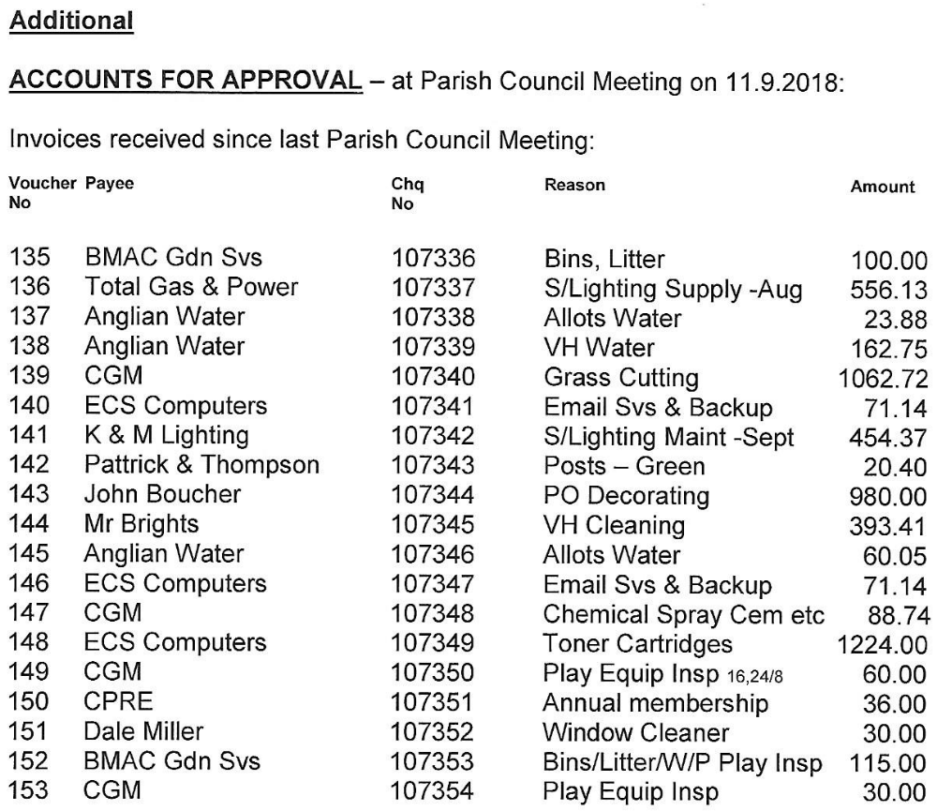

Bank balances as at 31.8.2018

Community Account 21,407.34
Step saver a/c 0.00
Treasury Deposit 230,000.00
Total £251,407.34

There being no further business the Chairman closed the meeting at 8.30pm.

10. NEXT MEETING: 7.00pm on Tuesday, 9th October 2018, in the Parish Council Meeting Room, South Wootton.

9th October 2018 Chairman

-76-

