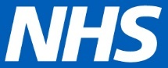

Coronavirus – how you can help yourself and the NHS (23 March 2020)
COVID-19 is a new illness that can affect your lungs and airways. It's caused by a virus called coronavirus. This update provides you with information on what you can do to look after yourself, your family, your community and the NHS. Please share it with your family, friends and community.

- Keep yourself up-to-date with the latest information
Visit nhs.uk/coronavirus for the latest information, including guidance on what to do if you have symptoms of coronavirus, advice on staying at home and what you can do to avoid catching and spreading the virus.
More information for people with existing health conditions is available from support organisations, such as: cystic fibrosis, asthma, diabetes, cancer and multiple sclerosis.

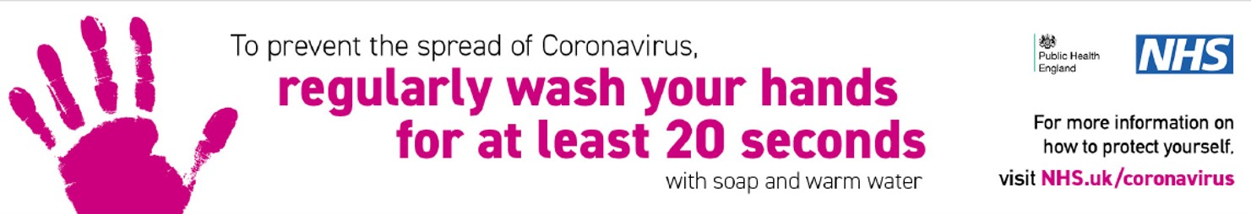

- Use the NHS App to order repeat prescriptions
Owned and run by the National Health Service, the NHS App is the simple and secure way to access a range of NHS services on your smartphone or tablet. Right now you can help the NHS by downloading the app and using it to order repeat prescriptions – it’s easy to do.
Download the NHS App on Apple’s App Store or get it on Google Play.

- Let your GP practice help you safely
Routine non-urgent services in the NHS could well come under pressure as a result of the coronavirus, and so the NHS is preparing a number of practical solutions to effectively respond to this outbreak.
If you have an appointment booked at your GP practice, or if you book one online, then they may call you to make sure that you see the right person in the right place for your illness. Your GP practice may encourage you to make use of more telephone and online appointments. Each practice will come up with slightly different arrangements depending on local needs and circumstances.
This is not something to be concerned about, but is being done as a precaution to help protect patients, staff and the public. You can help by following the advice of your GP practice.

- Visit your hospital’s website if you have an appointment or want to visit someone
Our hospitals are also making changes to how they care for people, this includes having more appointments over the phone and by using video calling, as well as changing how and when people can visit patients. These changes are being made to protect patients, staff and the public.
Visit your hospital’s website if you have questions about your appointments, procedures or visiting the hospital. Alternatively, the James Paget University Hospital and the Queen Elizabeth Hospital King’s Lynn have both set-up dedicated phone lines for people to call:
The number for the James Paget University Hospital phone line is 01493 453300.
The number for the Queen Elizabeth Hospital phone line is 01553 214545.

- Use the online 111 coronavirus service
It is really important that people use the online 111 coronavirus service if they can – people should only call 111 if they cannot get help online.
People should use the NHS 111 online coronavirus service if:
- they feel they cannot cope with their symptoms at home
- their condition gets worse
- their symptoms do not get better after 7 days

- Keep active and well
If you're stuck at home because of coronavirus, or your normal activity has been cancelled, it's still important to stay as active as you can. Even a small amount of activity will have a positive impact on your physical and mental health, and there's plenty you can do at home – visit Active Norfolk and One Life Suffolk for some ideas to keep you moving.
It's important to take care of your mind as well as your body. There are lots of tips and advice on the Every Mind Matters website about things you can do to help you keep on top of your mental wellbeing and cope with how you may feel while staying at home. Make sure you get further support if you feel you need it.
The Norfolk and Suffolk NHS Foundation Trust will also be updating their website every Wednesday at midday with new information, resources and materials. They're active on Facebook, Instagram and Twitter (#NSFTjoinin) too.

- Look after each other
The most immediate form of help you can provide to your community during this time is to look out for vulnerable neighbours. If you want to support a neighbour who is self-isolating, you can use one of these postcards to tell them that you're available. Information about helping others and staying safe if someone offers you help can be found on the Norfolk County Council website.

